

#Iteration WEBSITE

- Contact details were added in the header for both the websites.

2. Client logos updated in both the websites.

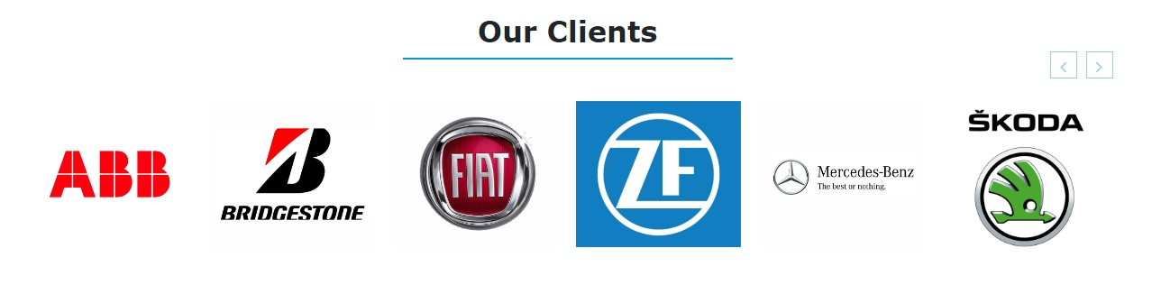

3. H1 tag updated in both the websites.

Task Marketing Reports WEBSITE

#Iteration WEBSITE

4. Language translator added in the header.

5. Updated Meta description in both the websites.

6. css and js files are minified and home page images are optimized.

7. Blog page created and posted the blogs

https://nihva.com/automatic-sliding-glass-doors-enhancing-health-and-safety-in-covid-time

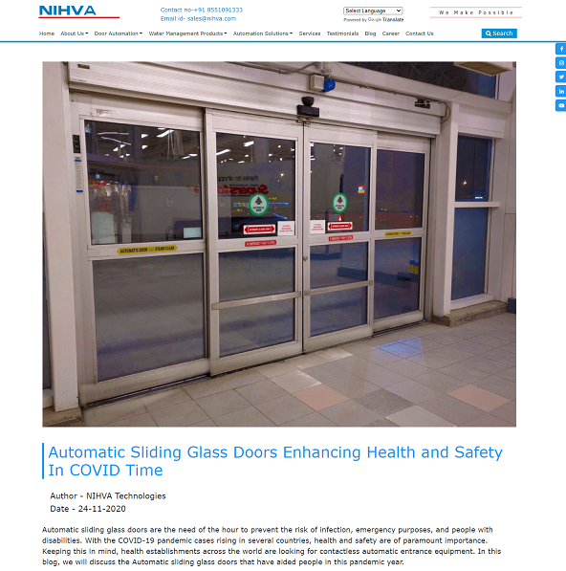

Task Marketing Reports WEBSITE

#Iteration WEBSITE

https://nihva.com/what-and-why-of-fire-rated-doors

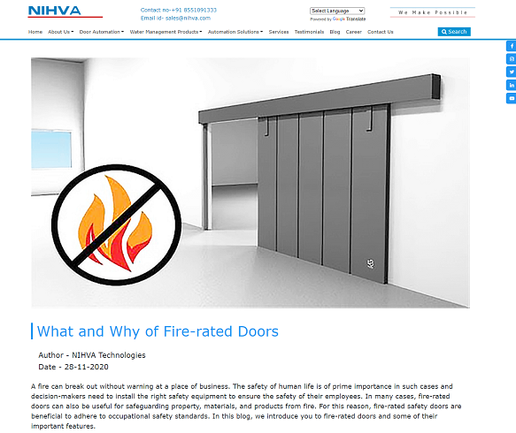

8. Broken links are removed from both the websites

Broken links are fixed

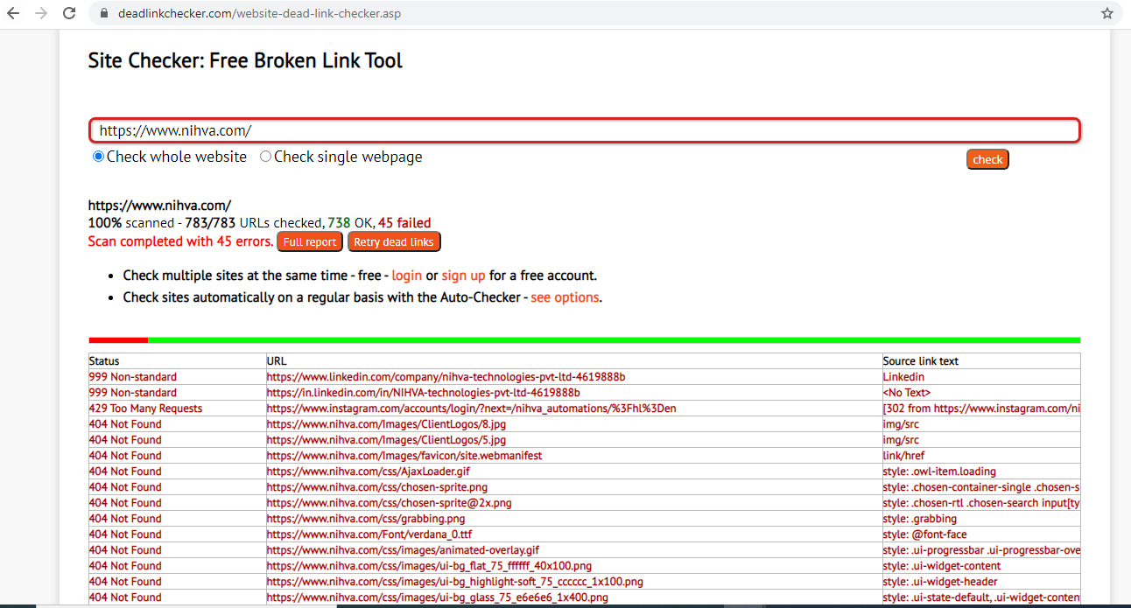

Before

Task Marketing Reports WEBSITE

#Iteration WEBSITE

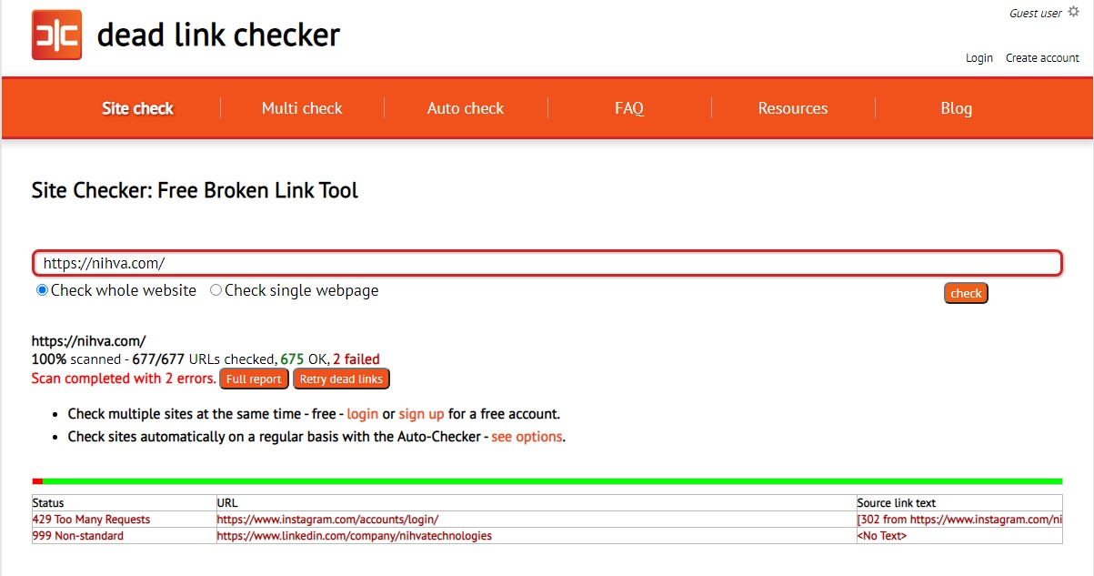

After

In the above error

999: Non-standard
This non-standard code is returned by some sites (e.g. linkedin) which do not permit scanning.

429: Working on this

Task Marketing Reports WEBSITE

#Iteration WEBSITE

9. Enquiry button made visible on every page

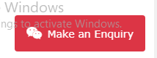

10. Half of the product page content is updated in the website and working on the remaining.

11. About us page mobile view alignment issue fixed.

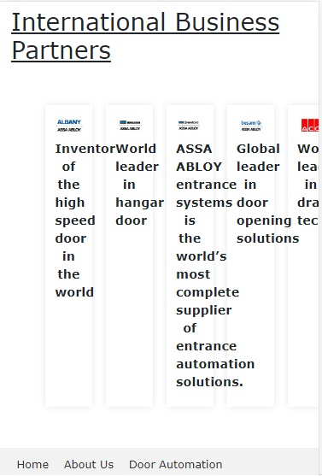

Before

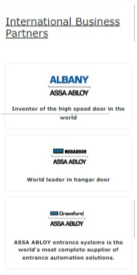
After

Task Marketing Reports WEBSITE

